Globally Harmonized System (GHS)

Introduction
This chapter will explain everything that’s needed to know about what is included in the new Hazard Communication Standard (HCS 2012) with the Globally Harmonized System (GHS). Simplify the requirements and give an outline on how and what needs to be included in the training of workers and employees.



The standard that gave workers the right to know, now gives them the right to understand.

The Hazard Communication Standard (HCS), also known as the Right-to-Know Law, was first enacted on November 25, 1983, by the Occupational Safety and Health Administration (OSHA). It was later modified with minor changes and technical amendments to take effect March 11, 1994. The standard is referenced by Title 29, Code of Federal Regulations (CFR) 1910.1200 and amended in the February 9, 1994, Federal Register. Modification of the prior Hazard Communication Standard (HCS) to conform with the United Nations' (UN) Globally Harmonized System of Classification and Labeling of Chemicals (GHS)

As of March 26, 2012, OSHA has adopted new hazardous chemical labeling requirements as a part of its recent revision of the Hazard Communication Standard, 29 CFR 1910.1200 (HCS), bringing it into alignment with the United Nations’ Globally Harmonized System of Classification and Labelling of Chemicals (GHS). These changes will help ensure improved quality and consistency in the classification and labeling of all chemicals, and will also enhance worker comprehension. As a result, workers will have better information available on the safe handling and use of hazardous chemicals, thereby helping them to avoid injuries and illnesses related to exposures to hazardous chemicals.

The revised HCS changes the existing Hazard Communication Standard (HCS/HazCom 19941) from a performance-based standard to one that has more structured requirements for the labeling of chemicals. The revised standard requires that information about chemical hazards be conveyed on labels using quick visual notations to alert the user, providing immediate recognition of the hazards. Labels must also provide instructions on how to handle the chemical so that chemical users are informed about how to protect themselves.

The Globally Harmonized System(GHS) is an international approach to hazard communication, providing a new system for classification of chemical hazards, and a standardized approach to labels and safety data sheets.

OSHA has modified the Hazard Communication Standard (HCS 2012) to adopt the Globally Harmonized System (GHS) to improve the safety and health of workers through more effective communications on chemical hazards.

OSHA is requiring that employees are trained on the new labels(e.g., pictograms and signal words) and Safety Data Sheet format.

OSHA states: “Workers have the right to know and understand the hazardous chemicals they use and how to work with them safely. Workers must be trained to understand the pictograms and the hazards that they represent.”

An effective "GHS Labels and Safety Data Sheets" training program will allow your employees to:
- Understand the new GHS label elements
- Identify the new GHS pictograms
- Read and interpret the new GHS Safety Data Sheets

"Exposure to hazardous chemicals is one of the most serious threats facing American workers today," said U.S. Secretary of Labor Hilda Solis. "Revising OSHA's Hazard Communication standard will improve the quality and consistency of hazard information, making it safer for workers to do their jobs and easier for employers to stay competitive."
The Hazard Communication Standard (HCS) is now aligned with the Globally Harmonized System of Classification and Labeling of Chemicals (GHS). This update to the Hazard Communication Standard (HCS) will provide a common and coherent approach to classifying chemicals and communicating hazard information on labels and safety data sheets. Once implemented, the revised standard will improve the quality and consistency of hazard information in the workplace, making it safer for workers by providing easily understandable information on appropriate handling and safe use of hazardous chemicals. This update will also help reduce trade barriers and result in productivity improvements for American businesses that regularly handle, store, and use hazardous chemicals while providing cost savings for American businesses that periodically update safety data sheets and labels for chemicals covered under the hazard communication standard.

OSHA Safety Manual also has a complete line of training products that include:

- Hazard Communication Standard / GHS Poster which explains everything as outlined in this chapter but is 24” x 39” to displace for easy employee reference.
- Complete Hazard Communication Training Program
- DVD - Hazard Communication Standard / GHS Training
- Large Pictogram Poster
- We also offer onsite training on the Hazard Communication Standard / GHS performed by a safety professional with a test administered afterward to ensure all of the pertanent information is retained and understood.

If you have any questions or need further help with training and implementation of the GHS & Hazard Communication Standard.

We can be reached at 800-347-1119 or www.OSHA Safety Manual.com

Hazard Communication Standard
OSHA revised its Hazard Communication Standard (HCS) to align with the United Nations’ Globally Harmonized System of Classification and Labeling of Chemicals (GHS) and published it in the Federal Register in March 2012 (77 FR 17574). Two significant changes contained in the revised standard require the use of new labeling elements and a standardized format for Safety Data Sheets (SDSs), formerly known as, Material Safety Data Sheets (MSDSs). The new label elements and SDS requirements will improve worker understanding of the hazards associated with the chemicals in their workplace. To help companies comply with the revised standard, OSHA is phasing in the specific requirements over several years (December 1, 2013 to June 1, 2016).

In order to ensure chemical safety in the workplace, information about the identities and hazards of the chemicals must be available and understandable to workers. OSHA's Hazard Communication Standard (HCS) requires the development and dissemination of such information:
- Chemical manufacturers and importers are required to evaluate the hazards of the chemicals they produce or import, and prepare labels and safety data sheets to convey the hazard information to their downstream customers;

- All employers with hazardous chemicals in their workplaces must have labels and safety data sheets for their exposed workers, and train them to handle the chemicals appropriately.

Major Changes to the Hazard Communication Standard
The four major areas of change are in hazard classification, labels, safety data sheets and information and training.

- Hazard classification: Provides specific criteria for classification of health and physical hazards, as well as classification of mixtures.
- Labels: Chemical manufacturers and importers will be required to provide a label that includes a harmonized signal word, pictogram, and hazard statement for each hazard class and category. Precautionary statements must also be provided.
- Safety Data Sheets: Will now have a specified 16-section format.
- Information and training: Employers are required to train workers by December 1, 2013 on the new labels elements and safety data sheets format to facilitate recognition and understanding.

The GHS does not include harmonized training provisions, but recognizes that training is essential to an effective hazard communication approach. The revised Hazard Communication Standard (HCS) requires that workers be re- trained within two years of the publication of the final rule to facilitate recognition and understanding of the new labels and safety data sheets.

For a side-by-side comparison of the current HCS and the final revised HCS please see OSHA's hazard communication safety and health topics webpage at:
http://www.osha.gov/dsg/hazcom/index.html

Dates and phase-in period in the revised Hazard Communication Standard
The table below summarizes the phase-in dates required under the revised Hazard Communication Standard (HCS):

Effective Completion Date | Requirement(s) | Who
December 1, 2013 | Train employees on the new label elements and safety data sheet (SDS) format. | Employers
June 1, 2015*  December 1, 2015 | Compliance with all modified provisions of this final rule, except:  The Distributor shall not ship containers labeled by the chemical manufacturer or importer unless it is a GHS label | Chemical manufacturers, importers, distributors and employers
June 1, 2016 | Update alternative workplace labeling and hazard communication program as necessary, and provide additional employee training for newly identified physical or health hazards. | Employers
Transition Period to the effective completion dates noted above | May comply with either 29 CFR 1910.1200 (the final standard), or the current standard, or both | Chemical manufacturers, importers, distributors, and employers

*This date coincides with the EU implementation date for classification of mixtures

During the phase-in period, employers would be required to be in compliance with either the existing HCS or the revised HCS, or both. OSHA recognizes that hazard communication programs will go through a period of time where labels and SDSs under both standards will be present in the workplace. This will be considered acceptable, and employers are not required to maintain two sets of labels and SDSs for compliance purposes.

Training on GHS Label Elements
The first compliance date of the revised HCS is December 1, 2013. By that time employers must have trained their workers on the new label elements and the SDS format. This training is needed early in the transition process since workers are already beginning to see the new labels and SDSs on the chemicals in their workplace. To ensure employees have the information they need to better protect themselves from chemical hazards in the workplace during the transition period, it is critical that employees understand the new label and SDS formats.

The list below contains the minimum required topics for the training that must be completed by December 1, 2013.

Training on label elements

Training on label elements must include information on:

• Type of information the employee would expect to see on the new labels, including the

- Product identifier: how the hazardous chemical is identified. This can be (but is not limited to) the chemical name, code number or batch number. The manufacturer, importer or distributor can decide the appropriate product identifier. The same product identifier must be both on the label and in Section 1 of the SDS (Identification).

- Signal words: used to indicate the relative level of severity of hazard and alert the reader to a potential hazard on the label. There are only two signal words, “Danger” and “Warning.” Within a specific hazard class, “Danger” is used for the more severe hazards and “Warning” is used for the less severe hazards. There will only be one signal word on the label no matter how many hazards a chemical may have. If one of the hazards warrants a “Danger” signal word and another warrants the signal word “Warning,” then only “Danger” should appear on the label.


- Pictogram or Symbols: OSHA’s required pictograms must be in the shape of a square set at a point and include a black hazard symbol on a white background with a red frame sufficiently wide enough to be clearly visible. A square red frame set at a point without a hazard symbol is not a pictogram and is not permitted on the label. OSHA has designated eight pictograms under this standard for application to a hazard category. Examples of all the pictograms and download
able files can be accessed on the UN website for the GHS at
http://www.unece.org/trans/danger/publi/ghs/pictograms.html

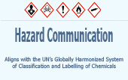
See the section below in the chapter titled “9 Pictogram or Symbols and Hazards”
for the detailed list of the Pictograms and associated hazards.

- Hazard statement(s): describe the nature of the hazard(s) of a chemical, including, where appropriate, the degree of hazard. For example: “Causes damage to kidneys through prolonged or repeated exposure when absorbed through the skin.” All of the applicable hazard statements must appear on the label. Hazard statements may be combined where appropriate to reduce redundancies and improve readability. The hazard statements are specific to the hazard classification categories, and chemical users should always see the same statement for the same hazards, no matter what the chemical is or who produces it.

- Precautionary statement(s): means a phrase that describes recommended measures that should be taken to minimize or prevent adverse effects resulting from exposure to a hazardous chemical or improper storage or handling.

- Supplier identification: Name, address and phone number of the chemical manufacturer, distributor, or importer

- Supplemental information: Non-harmonized information on the container of a hazardous product that is not required or specified under the GHS. Supplemental information may be used to provide further detail that does not contradict or cast doubt on the validity of the standardized hazard information.

• How an employee might use the labels in the workplace. For example,

- Explain how information on the label can be used to ensure proper storage of hazardous chemicals.

- Explain how the information on the label might be used to quickly locate information on first aid when needed by employees or emergency personnel.

- General understanding of how the elements work together on a label. For example,

- Explain that where a chemical has multiple hazards, different pictograms are used to identify the various hazards. The employee should expect to see the appropriate pictogram for the corresponding hazard class. ✓ Explain that when there are similar precautionary statements, the one providing the most protective information will be included on the label.

Safety Data Sheets (SDS) - Training

Training on the format of the SDS must include information on:

• Standardized 16-section format, including the type of information found in the various sections:

- For example, the employee should be instructed that with the new format, Section 8 (Exposure Controls/Personal Protection) will always contain information about exposure limits, engineering controls and ways to protect yourself, including personal protective equipment.

• How the information on the label is related to the SDS

- For example, explain that the precautionary statements would be the same on the label and on the SDS.

What is the GHS Safety Data Sheet (SDS)?

The (Material) Safety Data Sheet (SDS) provides comprehensive information for use in
workplace chemical management. Before this new implementation and changes were made to the Hazard Communication Standard the now Safety Data Sheet (SDS) was know as Material Safety Data Sheet or “MSDS.” This reference should not be made now as the new term is “SDS” - Safety Data Sheet (SDS).

Employers and workers use the SDS as sources of information about hazards and to obtain advice on safety precautions. The SDS is product related and, usually, is not able to provide information that is specific for any given workplace where the product may be used. However, the SDS information enables the employer to develop an active program of worker protection measures, including training, which is specific to the individual workplace and to consider any measures that may be necessary to protect the environment. Information in a SDS also provides a source of information for other target audiences such as those involved with the transport of dangerous goods, emergency responders, poison centers, those involved with the professional use of pesticides and consumers.

The SDS should contain 16 headings (Figure A). The GHS SDS headings, sequence and content are similar to the ISO, EU and ANSI MSDS/SDS requirements, except that the order of sections 2 and 3 have been reversed. The SDS should provide a clear description of the data used to identify the hazards. Figure A and the GHS Purple Book provide the minimum information that is required in each section of the SDS.

Figure A Minimum Information for an SDS

 | Heading | Subheading
1. | Identification | - Product identifier used on the label;  - Other means of identification;  - Recommended use of the chemical and restrictions on use;  - Name, address, and telephone number of the chemical manufacturer, importer, or other responsible party;  - Emergency phone number.
2. | Hazard(s) identification | - Classification of the chemical in accordance with paragraph (d) of  §1910.1200;  - Signal word, hazard statement(s), symbol(s) and precautionary statement(s) in accordance with paragraph (f) of §1910.1200. (Hazard symbols may be provided as graphical reproductions in black and white or the name of the symbol, e.g., flame, skull and crossbones);  - Describe any hazards not otherwise classified that have been identified during the classification process;  - Where an ingredient with unknown acute toxicity is used in a mixture at a concentration ≥ 1% and the mixture is not classified based on testing of the mixture as a whole, a statement that X% of the mixture consists of ingredient(s) of unknown acute toxicity is required.
3. | Composition/ information on ingredients | Except as provided for in paragraph (i) of §1910.1200 on trade secrets:  For Substances  - Chemical name;  - Common name and synonyms;  - CAS number and other unique identifiers;  - Impurities and stabilizing additives which are themselves classified and which contribute to the classification of the substance.  For Mixtures  In addition to the information required for substances:  - The chemical name and concentration (exact percentage) or concentration ranges of all ingredients which are classified as health hazards in accordance with paragraph (d) of §1910.1200 and  - Are present above their cut-off/concentration limits; or  - Present a health risk below the cut-off/concentration limits.  - The concentration (exact percentage) shall be specified unless a trade secret claim is made in accordance with paragraph (i) of §1910.1200, when there is batch-to-batch variability in the production of a mixture, or for a group of substantially similar mixtures (See A.0.5.1.2) with similar chemical composition. In these cases, concentration ranges may be used.  For All Chemicals Where a Trade Secret is Claimed  Where a trade secret is claimed in accordance with paragraph (i) of  §1910.1200, a statement that the specific chemical identity and/or exact percentage (concentration) of composition has been withheld as a trade secret is required.
4. | First-aid measures | - Description of necessary measures, subdivided according to the different routes of exposure, i.e., inhalation, skin and eye contact, and ingestion;  - Most important symptoms/effects, acute and delayed.  - Indication of immediate medical attention and special treatment needed, if necessary.
5. | Fire-fighting measures | - Suitable (and unsuitable) extinguishing media.  - Specific hazards arising from the chemical (e.g., nature of any hazardous combustion products).  - Special protective equipment and precautions for fire-fighters.
6. | Accidental release measures | - Personal precautions, protective equipment, and emergency procedures.  - Methods and materials for containment and cleaning up.
7. | Handling and storage | - Precautions for safe handling.  - Conditions for safe storage, including any incompatibilities.
8. | Exposure controls/personal protection | - OSHA permissible exposure limit (PEL), American Conference of Governmental Industrial Hygienists (ACGIH) Threshold Limit Value (TLV), and any other exposure limit used or recommended by the chemical manufacturer, importer, or employer preparing the safety data sheet, where available.  - Appropriate engineering controls.  - Individual protection measures, such as personal protective equipment.

 | Heading | Subheading

 | Heading | Subheading
9. | Physical and chemical properties | - Appearance (physical state, color, etc.);  - Odor;  - Odor threshold;  - pH;  - Melting point/freezing point;  - Initial boiling point and boiling range;  - Flash point;  - Evaporation rate;  - Flammability (solid, gas);  - Upper/lower flammability or explosive limits;  - Vapor pressure;  - Vapor density;  - Relative density;  - Solubility(ies);  - Partition coefficient: n-octanol/water;  - Auto-ignition temperature;  - Decomposition temperature;  - Viscosity.
10. | Stability and reactivity | - Reactivity;  - Chemical stability;  - Possibility of hazardous reactions;  - Conditions to avoid (e.g., static discharge, shock, or vibration);  - Incompatible materials;  - Hazardous decomposition products.
11. | Toxicological information | Description of the various toxicological (health) effects and the available data used to identify those effects, including:  - Information on the likely routes of exposure (inhalation, ingestion, skin and eye contact);  - Symptoms related to the physical, chemical and toxicological characteristics;  - Delayed and immediate effects and also chronic effects from short- and long-term exposure;  - Numerical measures of toxicity (such as acute toxicity estimates).  - Whether the hazardous chemical is listed in the National Toxicology Program (NTP) Report on Carcinogens (latest edition) or has been found to be a potential carcinogen in the International Agency for Research on Cancer (IARC) Monographs (latest edition), or by OSHA.
12. | Ecological information  (Non-mandatory) | - Ecotoxicity (aquatic and terrestrial, where available);  - Persistence and degradability;  - Bioaccumulative potential;  - Mobility in soil;  - Other adverse effects (such as hazardous to the ozone layer).
13. | Disposal considerations (Non-mandatory) | Description of waste residues and information on their safe handling and methods of disposal, including the disposal of any contaminated packaging.

 | Heading | Subheading
14. | Transport information  (Non-mandatory) | - UN number;  - UN proper shipping name;  - Transport hazard class(es);  - Packing group, if applicable;  - Environmental hazards (e.g., Marine pollutant (Yes/No));  - Transport in bulk (according to Annex II of MARPOL 73/78 and the IBC Code);  - Special precautions which a user needs to be aware of, or needs to comply with, in connection with transport or conveyance either within or outside their premises.
15. | Regulatory information  (Non-mandatory) | Safety, health and environmental regulations specific for the product in question.
16. | Other information, including date of preparation or last revision | The date of preparation of the SDS or the last change to it.

Hazard Classifications
The GHS Classification system is a complex system of data obtained from tests, literature, and practical experience. The main elements of the hazard classification are Physical Hazards, Health Hazards and Environmental Hazards as listed below:

Physical Hazards

- Explosives
- Oxidizing Gases
- Oxidizing Liquids
- Oxidizing Solids
- Gases Under Pressure
- Flammable Gas
- A Flammable Liquid
- A Flammable Solid
- A Flammable Aerosol
- A Pyrophoric Liquid
- A Pyrophoric Solid
- Self-Heating Substances
- Self-Reactive Substance
- Organic Peroxides
- Substances Corrosive to Metal
- Substances which on Contact with Water Emit Flammable Gases

Health Hazards

- Acute Toxicity
- Skin Corrosion
- Skin Irritation
- Serious Eye Damage
- Eye Irritation
- Respiratory Sensitizer
- Skin Sensitizer
- Germ Cell Mutagenicity
- Carcinogenicity
- Reproductive Toxicity
- Aspiration Hazard
- Specific Target Organ Toxicity (STOT)

Environmental Hazards

- Acute Aquatic Toxicity
- Chronic Aquatic Toxicity

Information and Training
December 1, 2013 – All employees who may be “exposed” to hazardous chemicals when working must be trained on the new elements ( GLOBALLY HARMONIZED SYSTEM OF CLASSIFICATION AND LABELING OF CHEMICALS) and safety data sheets (SDS).

1. “Exposure” or “exposed” under the rule means that an employee is subjected to a
hazardous chemical in the course of employment through any route of entry (inhalation,
ingestion, skin contact, or absorption) and includes potential or accidental exposure.

- Training may be done either by individual chemical, or by categories of hazard.

3. Employees must have access to the substance-specific information on the labels and
SDSs.

4. Employers must ensure, however, that employees are made aware of which hazard
category a chemical falls within.

5. Employees must understand the risks of exposure to the chemical(s) in their workplace as well as ways to protect themselves.

6. Create a climate where workers feel free to ask questions.

7. Make sure that training is understood by all workers who may be “exposed” to chemicals in the workplace.

8. HCS is to reduce the incidents of chemical source illness and injuries.

Checklist for GHS Compliance
The following checklist will help to ensure you comply with the REVISED HAZARD
COMMUNICATIONS STANDARD (HCS 2012):

___ 1. Obtain copy of the rule.
(Complete rule available at:
http:www.osha.gov/dsg/hazcom/ghs-final-rule.html )
___ 2. Read and understand the requirements.
___ 3. Assigned responsibility for tasks.
___ 4. Prepare inventory of chemicals.
___ 5. Obtain SDSs for each chemical.
___ 6. Ensure SDSs are available to workers.
___ 7. CONDUCT TRAINING OF WORKERS.
___ 8. Establish procedures to maintain current program.
___ 9. Establish procedures to evaluate effectiveness.

Assessing the Adequacy of your GHS Program
Does a list of the hazardous chemicals exist in each work area or at a central location?

- Are methods to inform workers of the hazards of non-routine tasks outlined?

- Are workers informed of the hazards associated with chemicals contained in the unlabeled pipes in work area?

- On multi-employer worksites, has the employer provided other employees with
information about labeling systems and precautionary measures?

- Is the written program made available to workers or their designated representatives?

Information and training are a critical part of the hazard communications program.
Employees obtain information regarding hazards and protective measures through
written labels and material safety data sheets (SDS). This is not always an easy task,
but the benefits are worth the effort.



9 Pictogram or Symbols and Hazards
There are nine pictograms under the GHS to convey the health, physical and environmental hazards. The final Hazard Communication Standard (HCS) requires eight of these pictograms, the exception being the environmental pictogram, as environmental hazards are not within OSHA's jurisdiction. The hazard pictograms and their corresponding hazards are shown below.

Health Hazard  • Carcinogen  • Mutagenicity  • Reproductive Toxicity  • Respiratory Sensitizer  • Target Organ Toxicity  • Aspiration Toxicity | Flame    • Flammables  • Pyrophorics  • Self-Heating  • Emits Flammable Gas  • Self-Reactives  • Organic Peroxides | Exclamation Mark    • Irritant (skin and eye)  • Skin Sensitizer  • Acute Toxicity (harmful)  • Narcotic Effects  • Respiratory Tract Irritant  • Hazardous to Ozone Layer  (Non Mandatory)
Gas Cylinder    • Gases under Pressure | Corrosion    • Skin Corrosion/ burns  • Eye Damage  • Corrosive to Metals | Exploding Bomb    • Explosives  • Self-Reactives  • Organic Peroxides
Flame over Circle    • Oxidizers | Environment  (Non Mandatory)    • Aquatic Toxicity | Skull and Crossbones  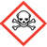  • Acute Toxicity (fatal or toxic)

Sample SDS Labels
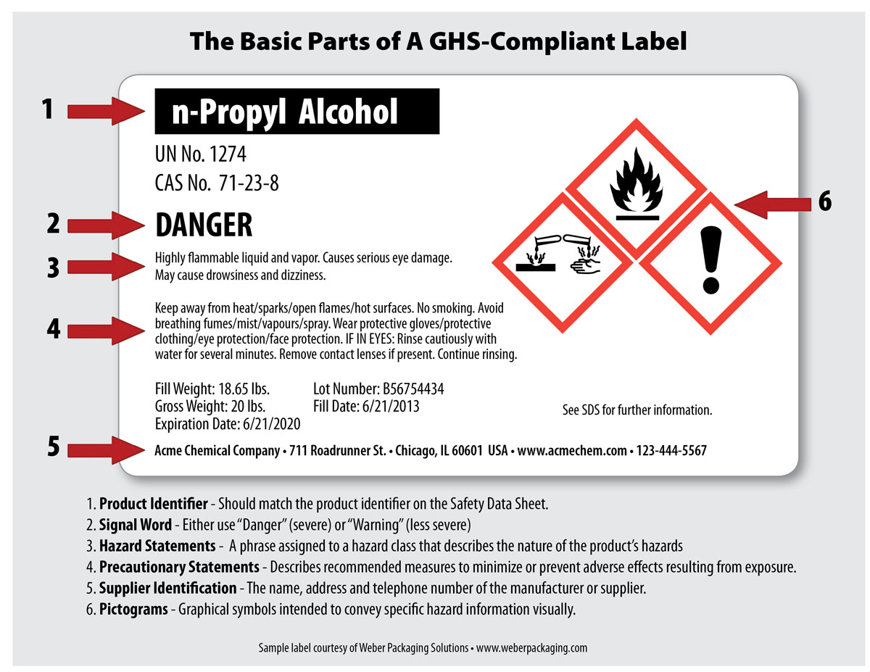

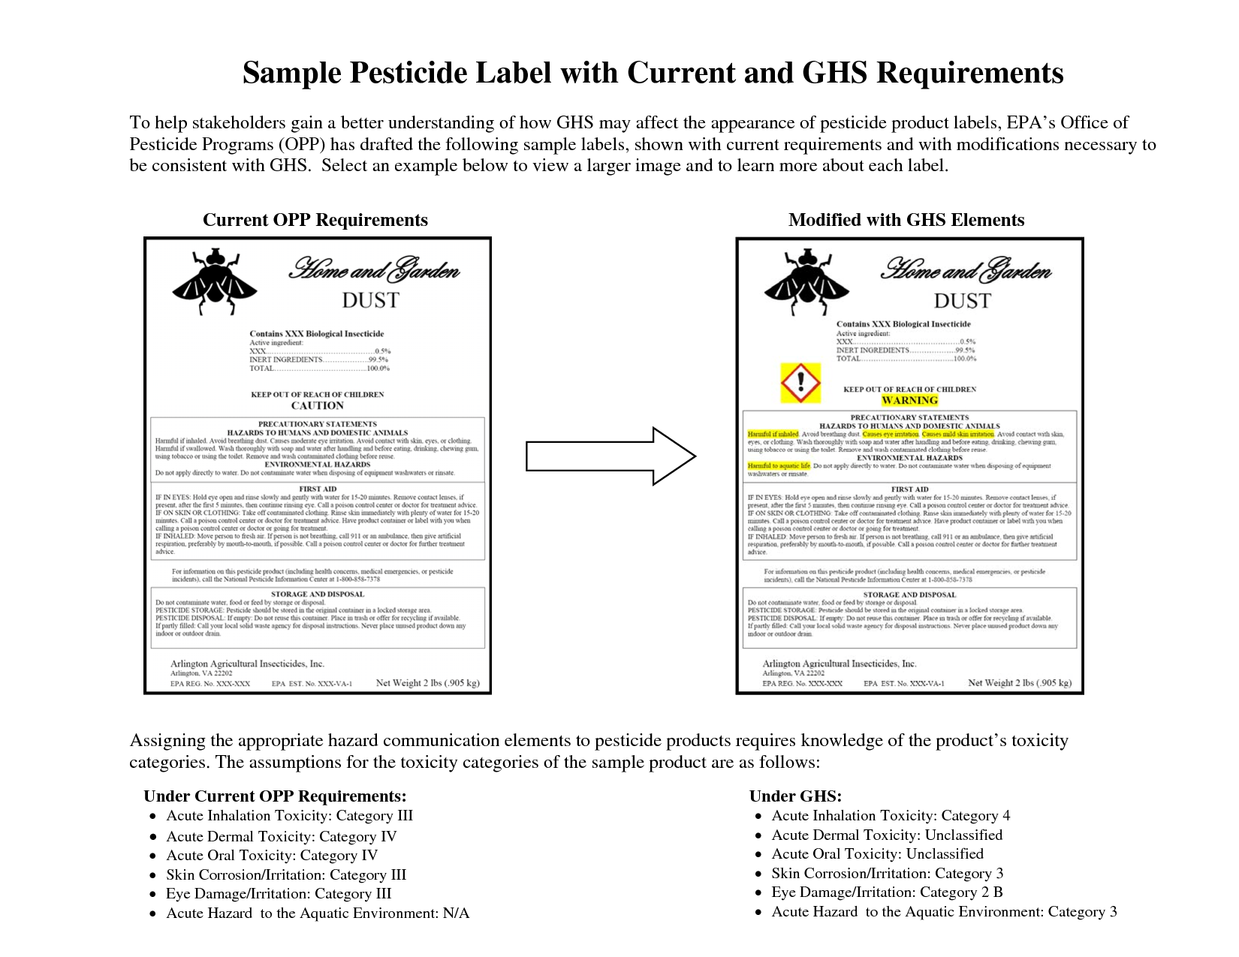
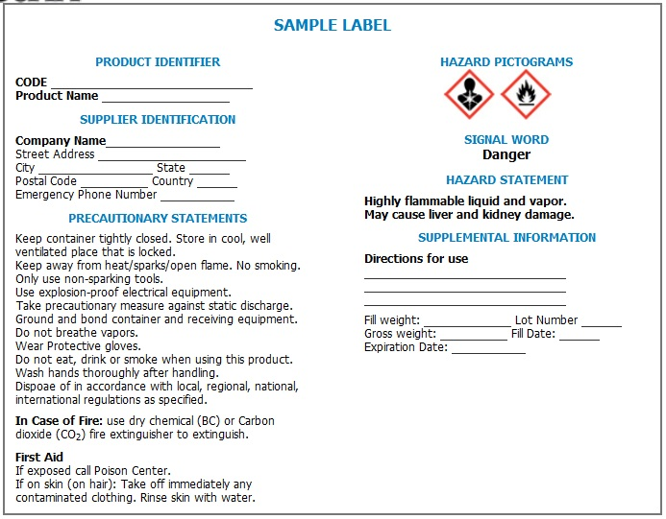

Conclusion
OSHA requires employers to present information in a manner and language that their employees can understand. If employers customarily need to communicate work instructions or other workplace information to employees in a language other than English, they will also need to provide safety and health training to employees in the same manner. Similarly, if the employee’s vocabulary is limited, the training must account for that limitation. By the same token, if employees are not literate, telling them to read training materials will not satisfy the employer’s training obligation.
OSHA’s Hazard Communication website http:// www.osha.gov/dsg/hazcom/index.html
has the following QuickCards and OSHA Briefs to assist employers with the required training.
  - Label QuickCard (English/Spanish)
  - Pictogram QuickCard (English/Spanish)
  - Safety Data Sheet QuickCard (English) (Spanish)
  - Safety Data Sheet OSHA Brief
  - Label/Pictogram OSHA Brief

(More information regarding appropriate training can be found in “Training Requirements in OSHA Standards and Training Guidelines “(OSHA 2254). A copy of this document is available from the Superintendent of Documents, Government Printing Office, P.O. Box 371954, Pittsburg, PA 15250-7954; (202)512-1800.

OSHA Safety Manual also has a complete line of training
products that include:

- Hazard Communication Standard / GHS Poster which explains everything as outlined in this chapter: 24” x 39” to display for easy employee reference.
- Large Pictogram Poster 24” x 24”
DISPLAYING THESE POSTERS SIGNIFY A COMMITMENT TO COMPLIANCE!!
ABOUT OUR POSTERS:
- Laminated on both sides and printed in high quality full color
- Complete Hazard Communication Training Program
- DVD - Hazard Communication Standard / GHS Training
- We also offer onsite training on the Hazard Communication Standard / GHS performed by a safety professional with a test administered afterward to ensure all of the pertanent information is retained and understood.

We can be reached at 800-347-1119 or www.OSHA Safety Manual.com

For a further understanding please review the following Q & A’s

Questions and Answers
Q. What is the Globally Harmonized System?

A. The Globally Harmonized System (GHS) is an international approach to hazard communication, providing agreed criteria for classification of chemical hazards, and a standardized approach to label elements and safety data sheets. The GHS was negotiated in a multi-year process by hazard communication experts from many different countries, international organizations, and stakeholder groups. It is based on major existing systems around the world, including OSHA's Hazard Communication Standard and the chemical classification and labeling systems of other US agencies.
The result of this negotiation process is the United Nations' document entitled "Globally Harmonized System of Classification and Labeling of Chemicals," commonly referred to as The Purple Book. This document provides harmonized classification criteria for health, physical, and environmental hazards of chemicals. It also includes standardized label elements that are assigned to these hazard classes and categories, and provide the appropriate signal words, pictograms, and hazard and precautionary statements to convey the hazards to users. A standardized order of information for safety data sheets is also provided. These recommendations can be used by regulatory authorities such as OSHA to establish mandatory requirements for hazard communication, but do not constitute a model regulation.

Q. Why did OSHA decide to modify the Hazard Communication Standard to adopt the GHS?

A. OSHA has modified the Hazard Communication Standard (HCS) to adopt the GHS to improve safety and health of workers through more effective communications on chemical hazards. Since it was first promulgated in 1983, the HCS has provided employers and employees extensive information about the chemicals in their workplaces. The original standard is performance-oriented, allowing chemical manufacturers and importers to convey information on labels and material safety data sheets in whatever format they choose. While the available information has been helpful in improving employee safety and health, a more standardized approach to classifying the hazards and conveying the information will be more effective, and provide further improvements in American workplaces. The GHS provides such a standardized approach, including detailed criteria for determining what hazardous effects a chemical poses, as well as standardized label elements assigned by hazard class and category. This will enhance both employer and worker comprehension of the hazards, which will help to ensure appropriate handling and safe use of workplace chemicals. In addition, the safety data sheet requirements establish an order of information that is standardized. The harmonized format of the safety data sheets will enable employers, workers, health professionals, and emergency responders to access the information more efficiently and effectively, thus increasing their utility.

Adoption of the GHS in the US and around the world will also help to improve information received from other countries—since the US is both a major importer and exporter of chemicals, American workers often see labels and safety data sheets from other countries. The diverse and sometimes conflicting national and international requirements can create confusion among those who seek to use hazard information effectively. For example, labels and safety data sheets may include symbols and hazard statements that are unfamiliar to readers or not well understood. Containers may be labeled with such a large volume of information that important statements are not easily recognized. Given the differences in hazard classification criteria, labels may also be incorrect when used in other countries. If countries around the world adopt the GHS, these problems will be minimized, and chemicals crossing borders will have consistent information, thus improving communication globally.

Q. Why must training be conducted prior to the compliance effective date?

A. OSHA is requiring that employees are trained on the new label elements (i.e., pictograms, hazard statements, precautionary statements, and signal words) and SDS format by December 1, 2013, while full compliance with the final rule will begin in 2015. OSHA believes that American workplaces will soon begin to receive labels and SDSs that are consistent with the GHS, since many American and foreign chemical manufacturers have already begun to produce HazCom 2012/GHS-compliant labels and SDSs. It is important to ensure that when employees begin to see the new labels and SDSs in their workplaces, they will be familiar with them, understand how to use them, and access the information effectively. For more information, http://www.osha.gov/dsg/hazcom/effectivedates.html.

Q. What Hazard Communication Standard provisions are unchanged in the revised HCS?

A. The revised Hazard Communication Standard (HCS) is a modification to the existing standard. The parts of the standard that did not relate to the GHS (such as the basic framework, scope, and exemptions) remained largely unchanged. There have been some modifications to terminology in order to align the revised HCS with language used in the GHS. For example, the term "hazard determination" has been changed to "hazard classification" and "material safety data sheet" was changed to "safety data sheet." OSHA stakeholders commented on this approach and found it to be appropriate.

Q. How will chemical hazard evaluation change under the revised Hazard Communication Standard?

A. Under both the current Hazard Communication Standard (HCS) and the revised HCS, an evaluation of chemical hazards must be performed considering the available scientific evidence concerning such hazards. Under the current HCS, the hazard determination provisions have definitions of hazard and the evaluator determines whether or not the data on a chemical meet those definitions. It is a performance-oriented approach that provides parameters for the evaluation, but not specific, detailed criteria. The hazard classification approach in the revised HCS is quite different. The revised HCS has specific criteria for each health and physical hazard, along with detailed instructions for hazard evaluation and determinations as to whether mixtures or substances are covered. It also establishes both hazard classes and hazard categories—for most of the effects; the classes are divided into categories that reflect the relative severity of the effect. The current HCS does not include categories for most of the health hazards covered, so this new approach provides additional information that can be related to the appropriate response to address the hazard. OSHA has included the general provisions for hazard classification in paragraph (d) of the revised rule, and added extensive appendixes (Appendixes A and B) that address the criteria for each health or physical effect.

Q. How will labels change under the revised Hazard Communication Standard?

A. Under the current Hazard Communication Standard (HCS), the label preparer must provide the identity of the chemical, and the appropriate hazard warnings. This may be done in a variety of ways, and the method to convey the information is left to the preparer. Under the revised HCS, once the hazard classification is completed, the standard specifies what information is to be provided for each hazard class and category. Labels will require the following elements:
- Pictogram: a symbol plus other graphic elements, such as a border, background pattern, or color that is intended to convey specific information about the hazards of a chemical. Each pictogram consists of a different symbol on a white background within a red square frame set on a point (i.e. a red diamond). There are nine pictograms under the GHS. However, only eight pictograms are required under the HCS.
- Signal words: a single word used to indicate the relative level of severity of hazard and alert the reader to a potential hazard on the label. The signal words used are "danger" and "warning." "Danger" is used for the more severe hazards, while "warning" is used for less severe hazards.
- Hazard Statement: a statement assigned to a hazard class and category that describes the nature of the hazard(s) of a chemical, including, where appropriate, the degree of hazard.
- Precautionary Statement: a phrase that describes recommended measures to be taken to minimize or prevent adverse effects resulting from exposure to a hazardous chemical, or improper storage or handling of a hazardous chemical.
Q. Can I use a black border on pictograms for domestic shipment?
A. Under the revised Hazard Communication Standard (HCS), pictograms must have red borders. OSHA believes that the use of the red frame will increase recognition and comprehensibility. Therefore, the red frame is required regardless of whether the shipment is domestic or international.
Q. Will OSHA allow blank red borders?
A. The revised Hazard Communication Standard (HCS) requires that all red borders printed on the label have a symbol printed inside it. If OSHA were to allow blank red borders, workers may be confused about what they mean and concerned that some information is missing. OSHA has determined that prohibiting the use of blank red borders on labels is necessary to provide the maximum recognition and impact of warning labels and to ensure that users do not get desensitized to the warnings placed on labels.
Q. When must label information be updated?
A. In the revised Hazard Communication Standard (HCS), OSHA is lifting the stay on enforcement regarding the provision to update labels when new information on hazards becomes available. Chemical manufacturers, importers, distributors, or employers who become newly aware of any significant information regarding the hazards of a chemical shall revise the labels for the chemical within six months of becoming aware of the new information, and shall ensure that labels on containers of hazardous chemicals shipped after that time contain the new information. If the chemical is not currently produced or imported, the chemical manufacturer, importer, distributor, or employer shall add the information to the label before the chemical is shipped or introduced into the workplace again.
Q. How will workplace labeling provisions be changing under the revised Hazard Communication Standard?
A. The current standard provides employers with flexibility regarding the type of system to be used in their workplaces and OSHA has retained that flexibility in the revised Hazard Communication Standard (HCS). Employers may choose to label workplace containers either with the same label that would be on shipped containers for the chemical under the revised rule, or with label alternatives that meet the requirements for the standard. Alternative labeling systems such as the National Fire Protection Association (NFPA) 704 Hazard Rating and the Hazardous Material Identification System (HMIS) are permitted for workplace containers. However, the information supplied on these labels must be consistent with the revised HCS, e.g., no conflicting hazard warnings or pictograms.
Q. How is the Safety Data Sheet (SDS) changing under the revised Hazard Communication Standard?
A. The information required on the safety data sheet (SDS) will remain essentially the same as that in the current standard (HazCom 1994). HazCom 1994 indicates what information has to be included on an SDS, but does not specify a format for presentation or order of information. The revised Hazard Communication Standard (HazCom 2012) requires that the information on the SDS be presented using specific headings in a specified sequence.
Paragraph (g) of the final rule provides the headings of information to be included on the SDS and the order in which they are to be provided. In addition, Appendix D provides the information to be included under each heading. The SDS format is the same as the ANSI standard format which is widely used in the U.S. and is already familiar to many employees.
The format of the 16-section SDS should include the following sections:
- Section 1. Identification
- Section 2. Hazard(s) identification
- Section 3. Composition/information on ingredients
- Section 4. First-Aid measures
- Section 5. Fire-fighting measures
- Section 6. Accidental release measures
- Section 7. Handling and storage
- Section 8. Exposure controls/personal protection
- Section 9. Physical and chemical properties
- Section 10. Stability and reactivity
- Section 11. Toxicological information
- Section 12. Ecological information
- Section 13. Disposal considerations
- Section 14. Transport information
- Section 15. Regulatory information
- Section 16. Other information, including date of preparation or last revision
The SDS must also contain Sections 12-15, to be consistent with the United Nations' Globally Harmonized System of Classification and Labeling of Chemicals (GHS). Although the headings for Sections 12-15 are mandatory, OSHA will not enforce the content of these four sections because these sections are within other agencies' jurisdictions.
Q. Will TLVs be required on the Safety Data Sheet (SDS)?
A. OSHA is retaining the requirement to include the American Conference of Government Industrial Hygienists (ACGIH) Threshold Limit Values (TLVs) on the safety data sheet (SDS) in the revised Standard. OSHA finds that requiring TLVs on the SDS will provide employers and employees with useful information to help them assess the hazards presented by their workplaces. In addition to TLVs, OSHA permissible exposure limits (PELs), and any other exposure limit used or recommended by the chemical manufacturer, importer, or employer preparing the safety data sheet are also required.
Q. May the International Agency for Research on Cancer (IARC) and the National Toxicology Program (NTP) lists be used to make carcinogen classifications?
A. In the revised Hazard Communication Standard (HCS), OSHA has provided classifiers with the option of relying on the classification listings of IARC and NTP to make classification decisions regarding carcinogenicity, rather than applying the criteria themselves. OSHA believes that this will make classification easier for classifiers, as well as lead to greater consistency. In addition, OSHA has provided in non-mandatory Appendix F of the revised rule, guidance on hazard classification for carcinogenicity. Part A of Appendix F includes background guidance provided by GHS based on the Preamble of the IARC "Monographs on the Evaluation of Carcinogenic Risks to Humans" (2006). Part B provides IARC classification information. Part C provides background guidance from the National NTP "Report on Carcinogens" (RoC), and Part D is a table that compares GHS carcinogen hazard categories to carcinogen classifications under IARC and NTP, allowing classifiers to be able to use information from IARC and NTP RoC carcinogen classifications to complete their classifications under the GHS, and thus the HCS.
Q. Will the International Agency for Research on Cancer (IARC) and the National Toxicology Program (NTP) classifications be required on the Safety Data Sheet (SDS)?
A. OSHA has retained the requirement to include IARC and NTP classifications on safety data sheets (SDSs). Therefore, if a chemical is listed as a carcinogen by either IARC or NTP, it must be noted on the SDS. Additionally, if OSHA finds a chemical to be a carcinogen, it must be noted on the SDS as well.
Q. How has OSHA addressed hazards covered under the current Hazard Communication Standard that have not been addressed by the GHS?
A. In the Notice of Proposed Rulemaking (NPRM), OSHA proposed to include hazards currently covered under the Hazard Communication Standard (HCS) that have yet to be addressed by the GHS (OSHA provided several examples: simple asphyxiants, and combustible dust) in a separate category called "Unclassified Hazards". In response to comments from the regulated community, OSHA has renamed the category to "Hazards Not Otherwise Classified (HNOC)" to minimize confusion. In the final HCS, HNOC hazards will not be required to be disclosed on the label but will be required to be disclosed in section 2 of the Safety Data Sheet (SDS). This reflects how GHS recommends these hazards should be disclosed. Chemical manufacturers and importers are expected to assess these hazards when they are conducting their hazard evaluation of physical and health hazards. A new or separate evaluation is not required. Also in the final standard, in response to comments, OSHA has removed pyrophoric gases, simple asphyxiants, and combustible dust from the HNOC hazard category and has addressed these chemicals individually (see question below for more information on each hazard).
Q. How has OSHA addressed pyrophoric gases, simple asphyxiants, and combustible dust?
A. In the revised Hazard Communication Standard (HCS), OSHA has added pyrophoric gases, simple asphyxiants and combustible dust to the definition of "hazardous chemical". OSHA has also added definitions to the revised HCS for pyrophoric gases and simple asphyxiants, and provided guidance on how to define combustible dust for the purposes of complying with the HCS.
- Pyrophoric gases:
OSHA has retained the definition for pyrophoric gases from the current HCS. Pyrophoric gases must be addressed both on container labels and SDSs. OSHA has provided label elements for pyrophoric gases which include the signal word "danger" and the hazard statement "catches fire spontaneously if exposed to air".
- Simple asphyxiants:
OSHA has revised the definition of simple asphyxiants that was proposed in the Notice of Proposed Rulemaking (NPRM) as a result of comments from the regulated community. In the final HCS, simple asphyxiants must be labeled where appropriate, and be addressed on SDSs. OSHA has provided label elements for simple asphyxiants which include the signal word "warning" and the hazard statement "may displace oxygen and cause rapid suffocation".
- Combustible dust:
OSHA has not provided a definition for combustible dust to the final HCS given ongoing activities in the specific rulemaking, as well as in the United Nations Sub-Committee of Experts on the GHS (UN/SCEGHS). However, guidance is being provided through existing documents, including the Combustible Dust National Emphasis Program Directive CPL 03-00-008, which includes an operative definition, as well as provides information about current responsibilities in this area. In addition, there are a number of voluntary industry consensus standards (particularly those of the NFPA) that address combustible dust.
In the final HCS, combustible dust hazards must be addressed on labels and SDSs. Label elements are provided for combustible dust in the final HCS and include the signal word "warning" and the hazard statement "May form combustible dust concentrations in the air".
For chemicals in a solid form that do not present a combustible dust hazard, but may form combustible dusts while being processed in normal downstream uses, paragraph (f)(4) of the HCS allows the chemical manufacturer some flexibility in labeling requirements. The manufacturer or importer may transmit the label to the customer at the time of the initial shipment, but the label does not need to be included with subsequent shipments unless it changes. This provides the needed information to the downstream users on the potential hazards in the workplace, while acknowledging that the solid metal or other materials do not present the same hazards that are produced when these materials are processed under normal conditions of use.
Q: How many businesses and workers would be affected by the revised Hazard Communication Standard?
A: OSHA estimates that over 5 million workplaces in the United States would be affected by the revised Hazard Communication Standard (HCS). These are all those workplaces where employees—a total of approximately 43 million of them—could be exposed to hazardous chemicals. Included among these 5 million workplaces are an estimated 90,000 establishments that create hazardous chemicals; these chemical producers employ almost 3 million workers.
Q: What are the estimated overall costs for industry to comply with the revised Hazard Communication Standard?
A: The revised Hazard Communications Standard's (HCS) total cost, an estimated $201 million a year on an annualized basis for the entire United States, is the sum of four major cost elements. (1) OSHA estimates that the cost of classifying chemical hazards in accordance with the GHS criteria and revising safety data sheets and labels to meet new format and content requirements would be $22.5 million a year on an annualized basis. (2) OSHA estimates that training for employees to become familiar with new warning symbols and the revised safety data sheet format under GHS would cost $95.4 million a year on an annualized basis. (3) OSHA estimated annualized costs of $59 million a year for management to become familiar with the new GHS system and to engage in other management-related activities as may be necessary for industry's adoption of GHS. (4) OSHA estimated annualized costs of $24.1 million for printing packaging and labels for hazardous chemicals in color.
Q: What are the estimated benefits attributable to the revised Hazard Communication Standard?
A: OSHA expects that the modifications to the Hazard Communication Standard (HCS) will result in increased safety and health for the affected employees and reduce the numbers of accidents, fatalities, injuries, and illnesses associated with exposures to hazardous chemicals. The GHS revisions to the HCS standard for labeling and safety data sheets would enable employees exposed to workplace chemicals to more quickly obtain and to more easily understand information about the hazards associated with those chemicals. In addition, the revisions to HCS are expected to improve the use of appropriate exposure controls and work practices that can reduce the safety and health risks associated with exposure to hazardous chemicals.
OSHA estimates that the revised HCS will result in the prevention of 43 fatalities and 585 injuries and illnesses (318 non-lost-workday injuries and illnesses, 203 lost-workday injuries and illnesses, and 64 chronic illnesses) annually. The monetized value of this reduction in occupational risks is an estimated $250 million a year on an annualized basis.
OSHA estimates that the revised HCS will result in savings of $475.2 million from productivity improvements for health and safety managers and logistics personnel, $32.2 million during periodic updating of SDSs and labels, and $285.3 million from simplified hazard communication training.
OSHA anticipates that, in addition to safety and health benefits, the revised HCS will result in four types of productivity benefits: (1) for chemical manufacturers, because they will need to produce fewer SDSs in future years; (2) for employers, in providing training to new employees as required by the existing OSHA HCS through the improved consistency of the labels and SDSs. (3) for firms engaging in, or considering engaging in, international trade.

Q. I understand that the United Nations revises the GHS every two years. How will OSHA manage and communicate changes to the Hazard Communication Standard?
A. It is expected that the GHS will be a living document and is expected to remain up-to-date and relevant; therefore further changes may be adopted on a two year cycle. Presently most of the recent updates have been clarification of text. However, OSHA anticipates that future updates of the Hazard Communication Standard (HCS) may be necessary and can be done through various rulemaking options, including:
- Technical updates for minor terminology changes,
- Direct Final Rules for text clarification, and
- Notice and Comment rulemaking for more substantive or controversial updates such as additional criteria or changes in health or safety hazard classes or categories.



